**JULY 13, 2018**

**User & Technical DOCUMENT**

*Identify and Access Management*

**BASHETTY ARUN KUMAR**

Master’s in computer security

EPITA - Kremlin-Bicetre

**Contents**

Purpose………………………………………………………………………………………….

Introduction………………………………………………………………………………….

Flow Chart…………………………………………………………………………………….

Login with Console…………………………………………………………………………

Create an identity ...............................................................................

Search an identity...............................................................................

Update an identity ..............................................................................

Delete an Identity ...............................................................................

Create User (login user) ……………………………………………………………………

Closing the program..............................................................................

Configuration Instructions......................................................................

**Purpose:**

* The purpose of the document is to make the user understand the project **Identity and Access Management.**

**Introduction :**

* This project help is saving users information i.e., User name, password and Display name. We have performed identity information system using of

1. Console application.

**Flow Chart:**

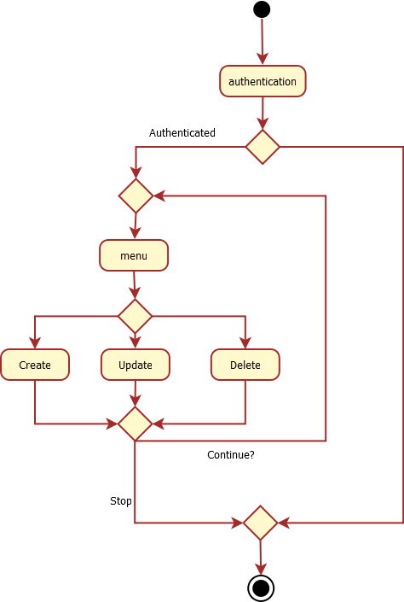

**Login:**

* In console application, user can login with unique credentials, if user name and password is not correct, this application is not worked.
* This working principle is called as authentication of application.

**Login with Console:**

* After Login by using user name and password, user will Successfully have logged in and it’s showing home page.

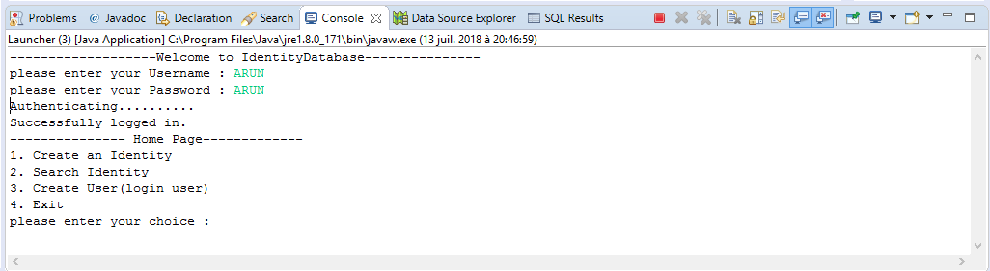

**Creating New Identity:**

* In home page, its displayed some identities from this if you clicked on 1 choice, you must create display name, email and uid.

After giving the details Identity successfully created.

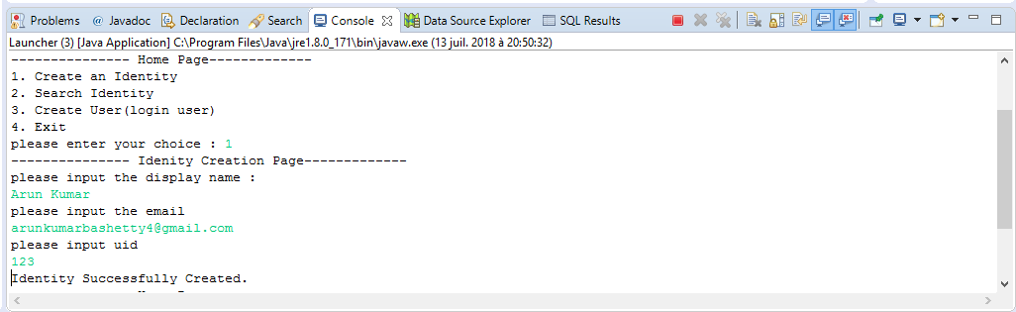

**Search an Identity:**

* In home page, if you click on option 2(Search Identity), it will show data which stored in data base.
* Here, it’s displays 2 identities,

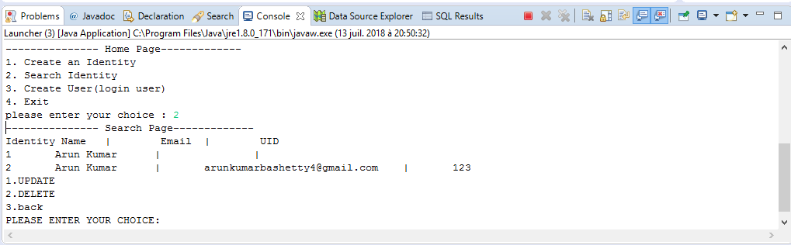

**Update an Identity:**

* In Updating Page, user can update the identities by clicking on options and its shows below information.

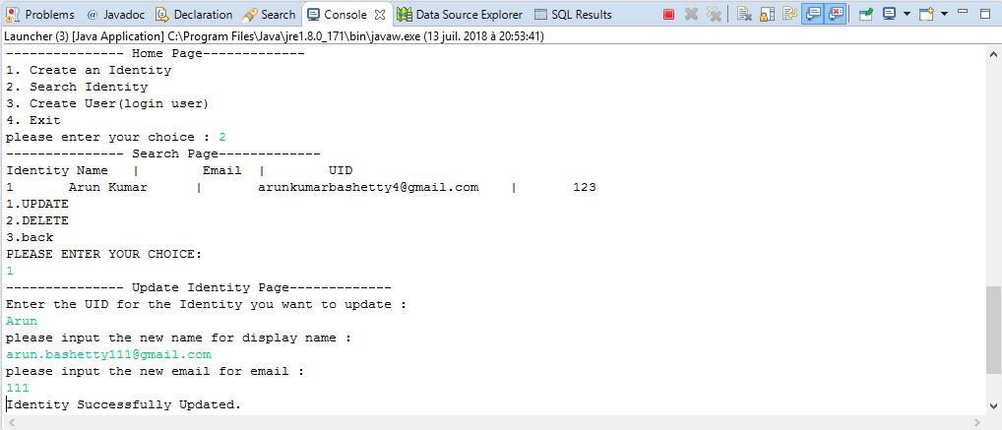

**Delete an Identity:**

* If user do not want any Identity, you can delete by clicking on option 2 in search Identity
* After clicking on this, Identity will have deleted successfully.

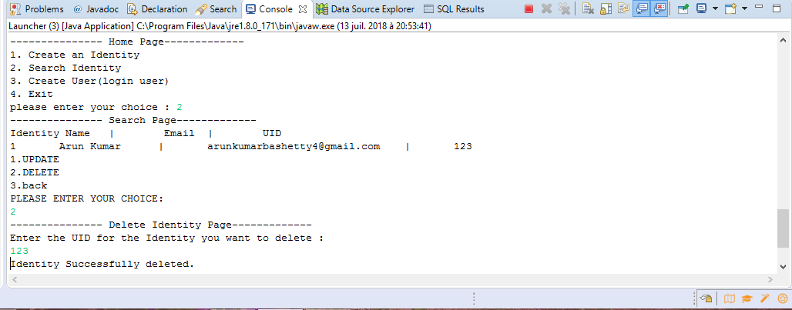

**We added one extra feature in Identity access Management i.e.,**

**Create User (login User):**

* If you want to change the user details like user name and password, you must enter new credentials and it’s displayed new User Successfully created.

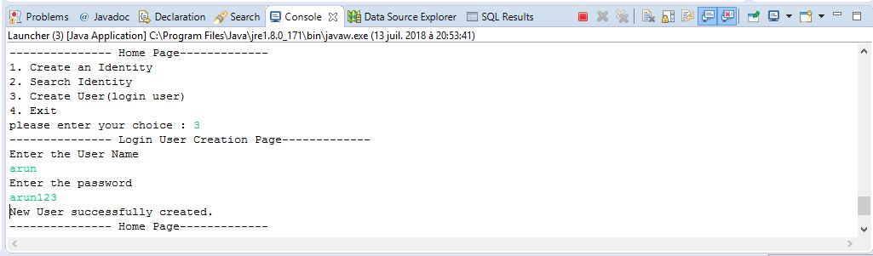

**Closing the program:**

* After done with your program, if you click on option 4 it will close the terminal and it’s displayed “……. Thank you… BYE…BYE…..”

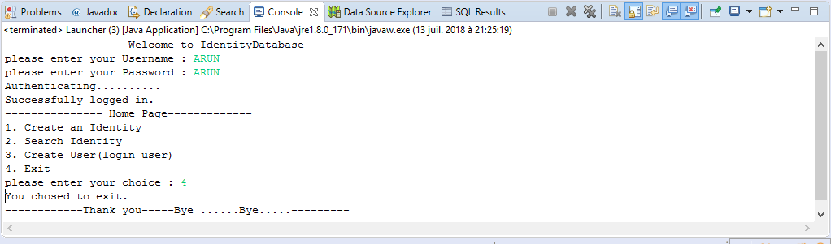

**Configuration Instructions:**

We should have installed the Java JDK file, Eclipse oxygen Java EE and the Derby

**For Derby Connection:**

You have to download, **db-derby-10.14.2.0-bin** from Web browser and after open , from bin floder you have click on startNetwork Server and it will shows below screenshot.

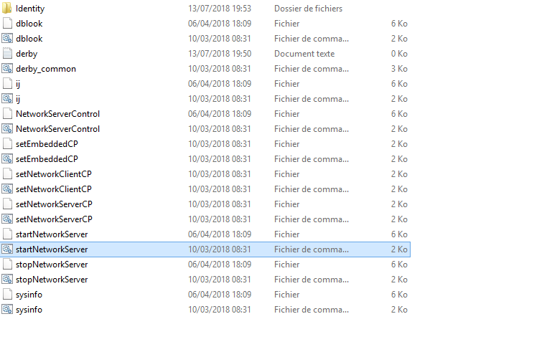

**Command Prompt:**

